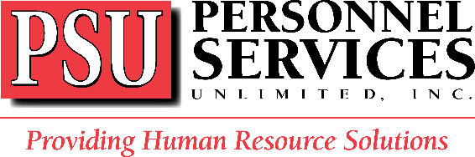

COVID-19 Letter to Employees
March 13, 2020

As a valued member of the Personnel Services Unlimited team, your health and well-being are important to us. The information in this document is from the U.S. Centers for Disease Control and Prevention and will help you understand how to reduce the chances of contracting the virus. Please read carefully and follow these guidelines.

Based on guidance from the U.S. Centers for Disease Control and Prevention,
PSU recommends that employees:

- Practice social distancing and maintain 6 feet from others.
- Avoid close contact with people who are sick.
- Avoid touching their eyes, nose, and mouth.
- Stay home when they are sick.
- Cover their cough or sneeze with a tissue, then throw the tissue in the trash.
- Clean and disinfect frequently touched objects and surfaces using a regular household cleaning spray or wipe.
- Not wear a face mask unless they show symptoms respiratory illness, including COVID-19.
- Wash their hands often with soap and water for at least 20 seconds, after going to the bathroom; before eating; and after blowing their nose, coughing, or sneezing (if soap and water are not readily available, use an alcohol-based hand sanitizer with at least 60% alcohol).

Employees who have questions or concerns regarding this information, attendance policies, or any other issue, should speak with immediate supervisor or call PSU.

To learn more about the novel coronavirus and keep up with the latest developments, see:
- About Coronavirus Disease 2019
- CDC’s Frequently Asked Questions and Answers
- CDC’s Handwashing

